St Mary’s School
Te Kura o Hata Maria

"As it is, these remain: faith, hope and love, the three of them; and the greatest of them is love." Corinthians, 13 - 13

What’s coming up term 2
Every Monday whole school prayer in the Church at 8.55am and every Friday assembly is 2.20pm also in the Church (unless stated differently)
Week 10  5-9 July  Gospel: Kiwi, Mrs Gray and Mrs Hansen | Longford Intermediate Production 12.30pm – Bellbird, Tui, Ruru and Piwakawaka - Tuesday 6th July  Senior School Production Auditions (year 5 and 6)  Thursday 8th July  Matariki Breakfast 8.50am in the quad  Friday 9th July – please note change of time  Mufti Mania for Caritas  Gold coin donation please - Friday 9th July  Friday term ends at the usual time 2.50pm
Church of the Blessed Sacrament
Saturday Vigil Mass 7.00pm

Sunday Mass 10.00am
No Children’s Liturgy

PLEASE NOTE the change in Mass times – Sunday morning Mass is 10.00am

Thursday 8th July 2021

Dear families,

The end of the term is here and just like that, we’re half way through our learning year. What a fun term we have had – Josh from Albion Excelsior in for rugby, Sarah in with the Sports Activator Programme, Confirmation, Cross Country (school, Eastern and Southland), busking, Emma and Cheyenne from Made to Move teaching Tapa Ae to our year 5 and 6’s, the Home and School Disco, Longford Intermediate’s Production, Mufti Mania, and our Matariki breakfast and heaps more! Phew, just typing that up has tired me out – aren’t our kids lucky to get so many amazing opportunites?

Next term there will be more amazing opportunities including Clued Up Kids for years 5 and 6, Father’s Day breakfast and liturgy, Pip and Harold with the Life Education Trust, First Holy Communion, Catholic Schools Day, year 6 Eastern Interschools Tournament and our Senior School Production – Cinderella, Rockerfella. Wow – so many exciting things to look forward to, I can’t wait!

Tomorrow we are hosting our annual Matariki breakfast which will start at 8.50am (please note the change in time), we would love to see you there. Children are also asked to wear mufti and bring a gold coin donation for this years Mufti Mania, the donations will go to Caritas who will help support children’s education in West Papua.

He aha te mea nui o te ao
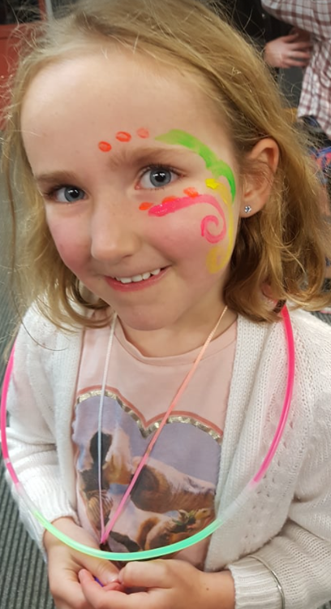
What is the most important thing in the world?
Changed Address or Phone Number?

Please let our Office Manager Di know so she can update your details at our end.

You can pop in and see her, call her 03 208 7733 or email her admin@stmarys.school.nz
He tangata, he tangata, he tangata
It is the people, it is the people, it is the people

We look forward to seeing you all back after the
holidays.

Cheers,
Mallory
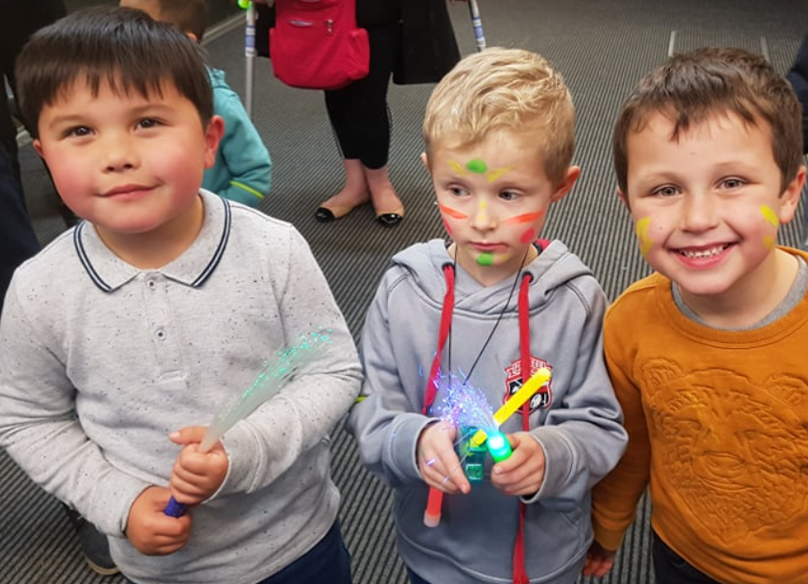

Home and School update
The Home and School Association AGM was held on 22nd June 2021, as advertised. Jacqui Byars and Leanne Kortbaoui stepped down as President and Secretary, respectively. Jacqui will remain active as a member; Leanne is stepping back altogether. We would like to extend a sincere thanks to Lee-Anne for her years of contribution, and especially her support creating both cookbooks; she has been a great asset to the committee.

We would also like to take this opportunity to thank Jacqui for her amazing work as President, and most especially for being the driving force behind the cookbooks, spring fair and other events run by the Home and School Association over the last few years.

Vanessa Bennett is stepping into the role as President, and Sarah Clinton as Secretary. Drew Goater remains as Treasurer.

In recent times Home & School has been supported by Gemma Perry, Rebekah Prattley, Chelsea Coyle, Tracy Ryan, Hilary Vallely, Dana Turnbull, Julie Bensemann, Trina Arygle, Trina Goater and Amy Thacker. Miss Sutherland and Mrs Nelson have attended as teacher representatives.
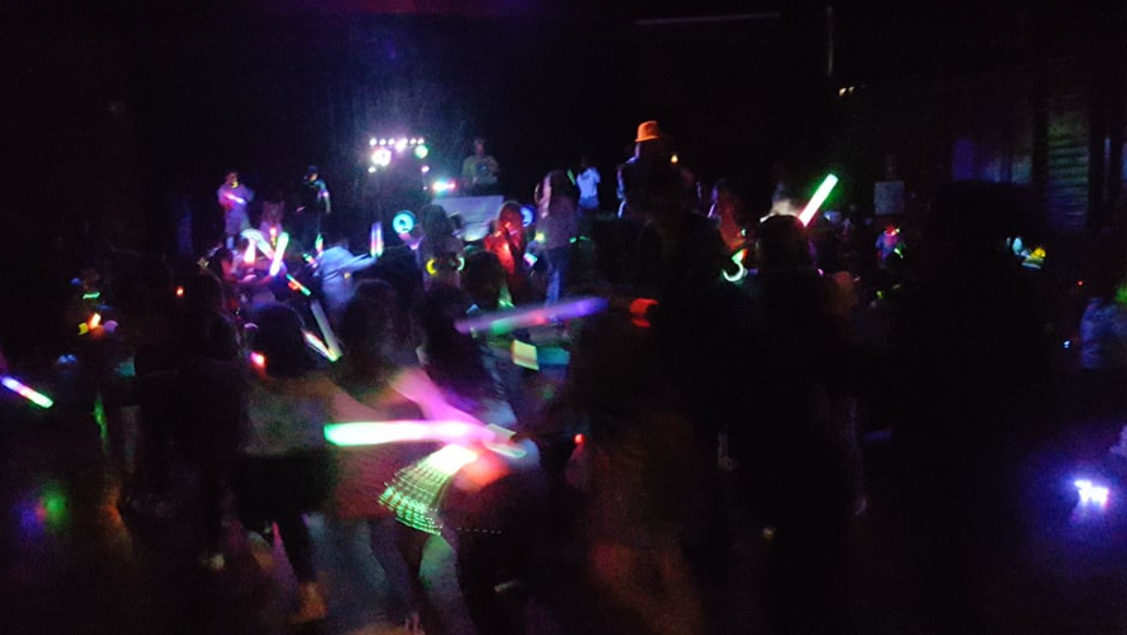
The disco held last Friday was a great success, all the kids had a great time, and we have received lovely feedback. Thank you, it means a lot. Each Term we would like to plan an event for the whole family to come along and enjoy. We will look forward to seeing you there.

If you would like to get involved, or know more about Home and School, feel free to get in touch with any of us, or Di in the office.

Vanessa Bennett
President

